**Recommended Reading**

The following books are suggested reading during bullying prevention week or whenever necessary as they teach non-discrimination practices. We are pleased to provide these books in our counseling offices and libraries for use by students and staff. The books are organized by grade level. Counselors distinguish which are used for individual, small group, classroom or whole class reading.

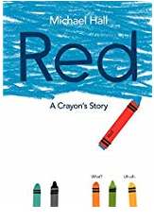A close up of a sign

Description generated with high confidence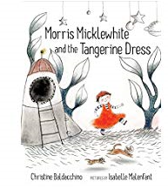

A picture containing text, book

Description generated with very high confidenceA person posing for a photo

Description generated with very high confidence

A close up of a device

Description generated with high confidenceA picture containing text

Description generated with high confidenceA close up of a sign

Description generated with high confidence**A picture containing text

Description generated with high confidence**