Mission Statement #1: To engage every student with the opportunity to thrive.
Q1. Please select the response that most closely matches how you feel about mission statement #1.
 | I strongly agree |  | I agree |  | I agree, with some reservations |  | I disagree |  | I strongly disagree |  | Did not answer |  | Total
Responses Received | 3 | 15.00% | 7 | 35.00% | 8 | 40.00% | 2 | 10.00% | 0 | 0% | 0 | 0% | 20

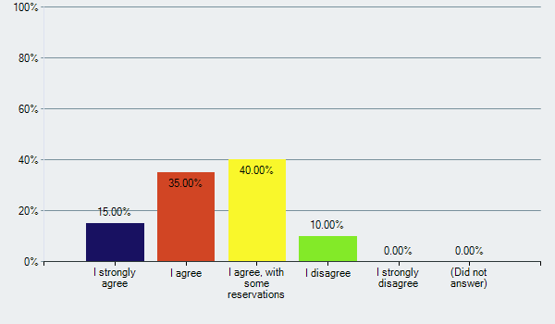

Q2. Please tell us what you like about this statement and the words that resonate with you.
SR No. | Response No. | Response Text
1 | 1 | I think the words engage and thrive are powerful and capture our mission.
2 | 2 | I like "engage with every student"
3 | 3 | Love the word thrive - applies to all students!
4 | 4 | I like the idea, to engage EVERY student.
5 | 5 | That it references "every student"
6 | 6 | I like the word "thrive" because it indicates growth of our students which all of our students can do.
7 | 7 | I like engage, every, and thrive -- but apart from "student" isn't really schools-related
8 | 8 | The well being of students is inherent in the statement, which focuses on student success Engage, every, opportunity, thrive
9 | 9 | I agree with the statement but it really doesn't say anything.
10 | 10 | I like the use of "opportunity" and "thrive"
11 | 11 | 'Engage' speaks directly to the purpose of being a learning institution. 'Every' is inclusive, 'opportunity' is our obligation, but it also assumes the student has some responsibility to carry through. 'Thrive' implies realizing ones potential and applying it to their life and career.
12 | 12 | This says that we at APS want all students to be successful and grow in their own way
13 | 13 | It has an action - engagement. That means that every student should feel engaged in some way with APS. It offers opportunities - meaning that not every student is the same but they get an opportunity to find what they succeed at and what challenges them. There are windows opened to be able to find their path through these opportunities. Thrive is a key word because not all students will find absolute success in everything they do, but they should find things that they thrive on, that drives them and excites them and they want to continue to learn more and it is a passion.
14 | 14 | I like the thought.
15 | 15 | LOVE the simplicity of it. Truly elegant. engage, opportunity are both good words. THRIVE is a superb word. Feels very open to a broad definition of what thrive means. And thrive also assumes that certain levels on Maslow's hierarchy (so I read SEL into it...because I want to).
16 | 16
17 | 17 | Engage and Opportunities are two en devours, I believe align with APS's mission.
18 | 18 | The sentence is inspiring APS students and families to take advantage of every opportunity.
19 | 19 | Overall this statement doesn’t make sense. I don’t think you engage with the opportunity. It doesn’t flow or grab attention. I like the phrase “every student”. It’s very inclusive.
20 | 20 | I like the word engage and thrive. But is feels incomplete

Q3. Is there anything you would either omit or change in this statement; if so, what is it?
SR No. | Response No. | Response Text
1 | 1 | To engage with the opportunity is awkward wording and forces you to think just a little too hard to get the message quickly.
2 | 2 | Bbut the opportunity to thrive is already here, it's not a matter of making more opportunity, but making sure everyone has access to it.
3 | 3
4 | 4 | I would like to see the part about the opportunity to thrive stated stronger to reflect our charge to provide the opportunities for our students.
5 | 5 | I don't like "engage" - it seems to "hands off" and lacking "accountability". Thrive is ambiguous and subjective.
6 | 6 | At the same time, it seems so broad I am not sure the community would know what does this mean.
7 | 7 | Bring APS/education into it more
8 | 8
9 | 9 | I'd define "thrive".
10 | 10
11 | 11 | No
12 | 12
13 | 13
14 | 14 | Engage can be an attempt. I would suggest provide. Opportunity to thrive is beyond APS control. I would offer: To provide every student with the skills necessary to succeed.
15 | 15 | i struggle with the logic of the statement - engage with opportunity. I want engage with learning, or with other people/community. But engaging with opportunity just doesn't make sense to me, nor does it inspire. maybe provide (or some more active version of that word) opportunity to thrive?
16 | 16 | I don't agree with the mission statement solely being focused on the students. I also think that it's to open to different thought bubbles in the different readers' head. I'm not a fan of this statement.
17 | 17 | I believe we are cultivating life long learning at APS, and the word "student" seems to focus on a point in time. I understand our charge is to focus on students, but I think we need to think of APS as a community of learners. That community includes teachers, family, staff and administration. I would like to see APS engage all learners (or foster a community of learners) with the opportunity to thrive. The word learner, or community of learners, I believe is more inclusive.
18 | 18 | No
19 | 19 | See above -
20 | 20 | The statement seems a little to simplistic for a Mission. Perhaps had "Engage every student and provide opportunities to learn and thrive

Mission Statement #2: Provide innovative, responsive and rigorous learning experiences that empower all students.
Q4. Please select the response that most closely matches how you feel about mission statement #2.
 | I strongly agree |  | I agree |  | I agree, with some reservations |  | I disagree |  | I strongly disagree |  | Did not answer |  | Total
Responses Received | 6 | 30.00% | 8 | 40.00% | 4 | 20.00% | 1 | 5.00% | 1 | 5.00% | 0 | 0% | 20

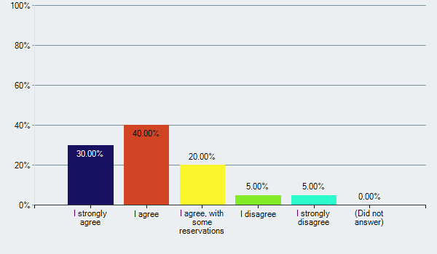

Q5. Please tell us what you like about this statement and the words that resonate with you.
SR No. | Response No. | Response Text
1 | 1 | To me this exactly captures what a school system is about.. I love every single word.
2 | 2 | all students, innovative, responsive, and empowerment
3 | 3 | Empower
4 | 4 | I like the idea o providing innovative, responsive and rigorous learning experiences.
5 | 5 | That it displays ownership or accountability with respect to the role of the APS towards its students.
6 | 6 | It sounds very similar to the first statement but more explicit. I like the idea that students are empowered to have agency over their experience.
7 | 7 | Responsive and rigorous
8 | 8 | The statement highlights experiencing learning and being active not passive about learning. Innovative, responsive, empower, all
9 | 9 | I like the words "innovative", "responsive", "rigorous", and "empower". It's a carefully worded sentence, each word has meaning.
10 | 10 | Love this one. Love innovative and responsive.
11 | 11 | focus on purpose of learning experience. 'Rigorous' resonates. 'Empower" is similar to 'enable as applied in first example.
12 | 12
13 | 13 | I feel that learning experiences is too limited. APS provides many experiences, but not all are connected just with learning. Experiences could be expanded upon rather than innovative, responsive and rigorous.
14 | 14 | Good thought.
15 | 15 | love 'empower all students'. Implies that students skills are built & strengthened, and then they're given the chance to actually DO something with all of that. responsive, also a very good word; to me it implies that we're meeting the students where they are and moving to where they need to be (academically, emotionally, socially...) rigorous, another good word. Implies high expectations, and not just academically.
16 | 16 | I like all of the words except provide. Even though this statement has students in it - I said I didn't like that narrow focus in Mission Statement #1 - here, I don't mind as much.
17 | 17 | I wholeheartedly agree that we should empower our learners . I agree that we should provide our learners with tools to take on challenging roles. I think "responsive" speaks to the variety of tools our learners need. This inspires "the importance of academic excellence;", but I'm worried its missing other items.
18 | 18
19 | 19 | I like the three descriptors that tell us what we are working towards in the educational experience.
20 | 20 | I like that it includes some of the values the group has identified - innovative, responsive and rigorous learning. Empowering students is very strong too, in my opinion.

Q6. Is there anything you would either omit or change in this statement; if so, what is it?
SR No. | Response No. | Response Text
1 | 1 | possibly add families to the end?
2 | 2 | n/a
3 | 3 | This statement feels very geared towards neurotypically developing children with no special needs. It feels exclusive of kids who may never be able to tackle “rigorous” work.
4 | 4 | no.
5 | 5 | Too many ambiguous words - "innovative", "rigorous", and "responsive"
6 | 6 | Unclear about the meaning of the word responsive. Does this relate to personalized education? If so, I would oppose that.
7 | 7 | Innovative -- don't need to always innovate, if something works we should just do it
8 | 8 | While the sense of the statement is active, saying provide doe not indicate the students accept or use the opportunities. Also, "rigorous" in the context of stress for many students may be too strong. Rearrange the statement to say: Empower all students with innovative, responsive, and challenging learning experiences.
9 | 9
10 | 10
11 | 11 | Change the word 'provide' to something more inspirational.
12 | 12
13 | 13 | Provide all students with experiences that culture innovation, engage healthy interactions and promote rigorous learning
14 | 14 | No changes.
15 | 15 | Innovative is a bit over-used, in my opinion...cutting edge (nah, also becoming cliche)...inventive? maybe. provide is also very passive...but can't find a better word in my thesaurus.
16 | 16 | I might suggest swapping "provide" with "ensure", even though that might make other changes needed. Maybe a stronger word is "guarantees".
17 | 17 | My concern with this statement, is the missing "ethics" and "community" focus.
18 | 18
19 | 19 | Too many words - but not sure what you would take out!
20 | 20 | I like it, but perhaps expand on the concept of empowering students " to achieve their personal best )

Mission Statement #3: Cultivating passionate, confident global learners who are motivated to improve themselves and the world around them.
Q7. Please select the response that most closely matches how you feel about mission statement #3.
 | I strongly agree |  | I agree |  | I agree, with some reservations |  | I disagree |  | I strongly disagree |  | Did not answer |  | Total
Responses Received | 5 | 25.00% | 7 | 35.00% | 5 | 25.00% | 0 | 0% | 2 | 10.00% | 1 | 5.00% | 20

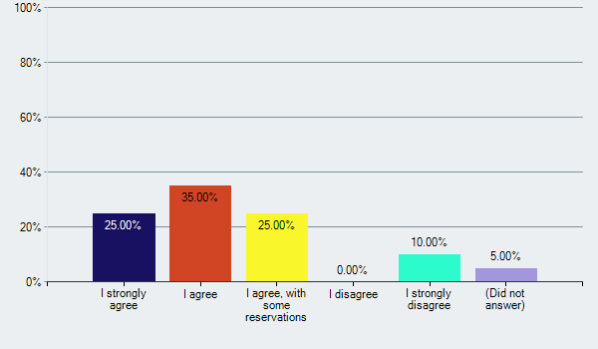

Q8. Please tell us what you like about this statement and the words that resonate with you.
SR No. | Response No. | Response Text
1 | 1 | cultivate passionate
2 | 2
3 | 3 | It is positive
4 | 4 | cultivating, confident, motivated
5 | 5 | That it recognizes global learning and the world around them.
6 | 6 | I like the sentiment of the statement but would change the wording to maybe "Cultivating curious and adept learners who strive for personal growth" and . . .
7 | 7 | Confident, learners, also speaks to what they will be like after APS
8 | 8 | Cultivating, confident, learners, motivated, improve The statement is focused on students, which fits the Charge.
9 | 9 | I like all of it. The words that resonate are "passionate", "global", "learners", and the phrase "motivated to improve themselves and the world around them".
10 | 10 | Like the word "cultivating".
11 | 11 | I like the energy, words like 'cultivating', 'passionate', 'confident' and 'motivated'.
12 | 12
13 | 13 | This is a word jumble. Starting the sentence with "cultivating passionate...." and then turn into "who are" sounds a bit odd.
14 | 14 | Good thought.
15 | 15 | love the words - cultivate (nourish, nurture, help to grow - passionate, implies desire, fire within - confident, they are self-assured and able to do things. global - sense of the world, its diversity; also implies a well-rounded education learners...not students, but learners. on a journey of discover motivated...they're moving forward! improving selves and world around them...APS kids aren't sitting still. They are on an upward trajectory. full disclosure - I was one of the authors of this one.
16 | 16 | I like the word cultivating and I appreciate having passion in the statement. I'm not clear what a confident learner really means. Plus, I would delete motivated, we don't want the motivation but rather the action of improving self and the world.
17 | 17 | I enjoy the use of global learners, and the term "cultivating". I think both terms speak to what the community aspires to do with our investment in APS.
18 | 18
19 | 19 | I like the words global, confidant and motivated as well as the idea of working towards improvement. I like the forward thinking of that language - that APS is working towards something.
20 | 20 | I like this statement the most because it includes some concepts that I believe will be important for future citizens of the world

Q9. Is there anything you would either omit or change in this statement; if so, what is it?
SR No. | Response No. | Response Text
1 | 1 | To cultivate confident and passionate learners who strive to enact change in the community.
2 | 2
3 | 3 | Way too long
4 | 4 | global learners may need some explanation to some
5 | 5 | Don't like "improve themselves" - makes it seem like there is something flawed with APS students.
6 | 6 | Eliminate anything related to global learning or learners. Our group discussed this phrase and think it doesn't really have meaning - just sounds good.
7 | 7
8 | 8 | Passionate is good if it is about global learning, but it also can lead to emotional ties that could impede the goal of improving self and others. "Passionate" can be deleted.
9 | 9
10 | 10 | This is too clunky, also, not sure about the improve the world around them language in a mission statement--seems vision-y.
11 | 11 | Not sure what 'global learners' implies. Are they learning about world events? Becoming diplomats? May be too often mis-understood.
12 | 12
13 | 13 | APS will provide opportunities to cultivate passionate and confident global learners who are motivated to improve themselves and the world around them.
14 | 14 | No changes.
15 | 15 | It IS long. Maybe Original: Cultivating passionate, confident global learners who are motivated to improve themselves and the world around them. Option 1: Cultivating passionate, confident global learners who seek to improve themselves and the world around them. Option 2: Cultivating passionate, confident global learners who improve themselves and the world around them. I want it to be shorter, but can't find better way to capture the last phrase.
16 | 16
17 | 17 | "who are motivated to improve themselves and the world around them." This sentence both inspires and causes me reservation at the same time. By who's standard are they "improving" themselves? Also, I'm worried it sends a message that only one way of improving is desired (college bound). I like the direction of the sentence, but I think we need to revisit the words used here.
18 | 18
19 | 19 | Wordy and not sure we can cultivate passion. Also doesn’t make it clear we are talking about ALL learners.
20 | 20 | No, it works as is, I think

Vision Statement #1: Our learners find solutions.
Q10. Please select the response that most closely matches how you feel about vision statement #1.
 | I strongly agree |  | I agree |  | I agree, with some reservations |  | I disagree |  | I strongly disagree |  | Did not answer |  | Total
Responses Received | 3 | 15.00% | 6 | 30.00% | 5 | 25.00% | 3 | 15.00% | 3 | 15.00% | 0 | 0% | 20

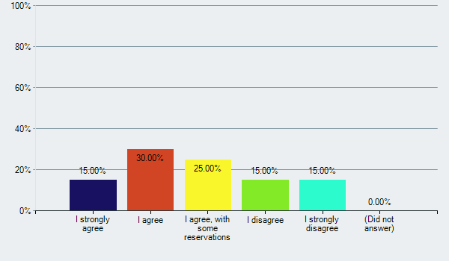

Q11. Please tell us what you like about this statement and the words that resonate with you.
SR No. | Response No. | Response Text
1 | 1 | solutions I like the brevity that encompasses everything. I think this covers our base of Pre K through 12 and beyond.
2 | 2
3 | 3 | None
4 | 4 | While I like the idea, I find it unrealistic without further explanation.
5 | 5
6 | 6 | I like its simplicity of the statement.
7 | 7
8 | 8 | The statement can apply to everyone in APS and encourages staff as well as all levels of student. It claims the learners as ours and celebrates the learner finding a solution, whether it is small and personal or global.
9 | 9 | Our learners have to find solutions.
10 | 10 | Seems limited--not really a comprehensive vision. But, I really like how pithy it is.
11 | 11 | Snappy, perhaps something everyone can rally around - staff, teachers, parents. I like that it describes the change we hope to see - 'solutions'
12 | 12 | Solutions resonates with me. We want our students to find answers to questions that they may and even question the question they are trying to find the answer to.
13 | 13 | I would be disappointed if this was our vision statement. It puts no responsibility on APS, the community or the families and just says (to me) "here, go find your own path and solution, good luck"
14 | 14 | Learners? Is students no longer PC?
15 | 15 | simple, elegant. very positive and speaks well of kids coming out of APS looking for problems, finding solutions for them. using learners as a word implies ongoing learning too -it never ends...
16 | 16
17 | 17 | I admire the brevity in it. I support the use of "learners".
18 | 18
19 | 19 | Short, simple yet clear and covers everything.
20 | 20 | I like the simplicity of the statement.

Q12. Is there anything you would either omit or change in this statement; if so, what is it?
SR No. | Response No. | Response Text
1 | 1 | no
2 | 2
3 | 3 | Too trite
4 | 4 | While I like the idea, I find it unrealistic without further explanation.
5 | 5 | HATE THIS ONE! Hate the reference to students as "learners" and "find solutions". Simplicity did not do this one any favors.
6 | 6 | All learning is not about finding solutions. Learning can be about personal growth. The statement seems finite. Identify problem - find solution. I don't think that is a vision for APS.
7 | 7 | I think this statement is likely to frustrate many who have kids with learning challenges, for whom making it is the goal -- finding a solution sounds ambitious
8 | 8 | The statement may seem too short, but adding more to it risks excluding some aspects of the APS values.
9 | 9 | There is so much more to learning than finding solutions.
10 | 10
11 | 11 | Feels somewhat like a tag line.
12 | 12
13 | 13 | I would not be happy using this.
14 | 14 | Learners? Is "students" no longer PC? Are we saying that if they don't find solutions, they are failures? I would offer: Our students seek solutions.
15 | 15 | feel like I want something that qualifies more of solutions to what? But I'm not stuck on that too much.
16 | 16 | I don't feel aspirational with this statement.
17 | 17 | "find solutions" I'm cautious about this part of the vision. My hope is to have learners that feel comfortable learning from their mistakes, and that hold themselves accountable for the solutions they introduce to the world. While finding solutions is important, it is equally as important weighing the impact of those solutions not just the intent.
18 | 18
19 | 19 | No - I really appreciate the simplicity.
20 | 20 | It lacks some clarity. Perhaps it is a bit too simplistic. It may benefit from expanding on solutions. Perhaps something like ... innovative solutions to community and global challenges. Not sure!

Vision Statement #2: APS attracts and retains dedicated and driven educators who support and facilitate equal access for all students' emotional, mental and academic opportunities through an integrated curriculum that allows students to graduate to diverse opportunities and go on to impact the world beyond them.
Q13. Please select the response that most closely matches how you feel about vision statement #2.
 | I strongly agree |  | I agree |  | I agree, with some reservations |  | I disagree |  | I strongly disagree |  | Did not answer |  | Total
Responses Received | 4 | 20.00% | 5 | 25.00% | 8 | 40.00% | 2 | 10.00% | 1 | 5.00% | 0 | 0% | 20

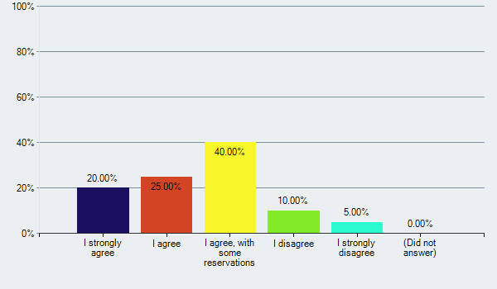

Q14. Please tell us what you like about this statement and the words that resonate with you.
SR No. | Response No. | Response Text
1 | 1 | equal access
2 | 2
3 | 3 | None
4 | 4 | I like the entire statement although it is very wordy.
5 | 5 | That it encompasses educators, students and the world beyond them.
6 | 6 | I like that it encompasses the components of staff, equity, whole child, integrated curriculum and future opportunities.
7 | 7
8 | 8 | Dedicated, driven, educators, equal access, emotional, mental, opportunities, integrated, impact
9 | 9
10 | 10 | It is comprehensive.
11 | 11 | describes a comprehensive journey of all that is required to produce high quality graduates who are ready to take on the world's opportunities and challenges.
12 | 12
13 | 13 | I feel like this just grabs every hot word regarding strategic planning without having a precise direction. It is very wordy without an end result. It does not answer the question "why"
14 | 14 | Good thought.
15 | 15 | like the focus on educators as part of our future equal access is important too! full range of emotional, mental, and adademic 'graduate to diverse opportunities and go on to impact the world beyond them' as beautiful as a concept and could be the foundation of a vision statement.
16 | 16 | I like the broad focus of educators and students. I like also supporting and facilitating equal access for the whole child's needs.
17 | 17 | Yes! Our educators (from the front office, to ext day, to the classrooms) they differentiate APS. I would like to see APS foster this amazing team, because our community of learners benefits from it. I love a future where APS graduates all of their learners to diverse opportunities and go on to impact the world beyond them.
18 | 18
19 | 19 | I like how inclusive it is and that it includes APS staff and refers to the future for the students.
20 | 20 | Too lengthy for a Vision statement and covering too many concepts that are presumed. it is almost more appropriate as a Mission statement with some edits

Q15. Is there anything you would either omit or change in this statement; if so, what is it?
SR No. | Response No. | Response Text
1 | 1 | To provide all students with equal access to integrated academic, social and emotional learning experiences that allow them to be successful and impactful within their communities.
2 | 2
3 | 3 | Way too long. Doesn’t start with students.
4 | 4 | A bit meaty.
5 | 5 | It's long. Maybe find a more succinct way to infer the following phrases: "students' emotional, mental and academic opportunities"; "integrated curriculum"; "diverse opportunities"; and "and go on to impact the world beyond them".
6 | 6 | I would like to the statement to be simple. Work of wording of the emotional, mental, and academic opportunities. What does that mean? What does it look like? "Impact the world beyond them" can be positive or negative.
7 | 7 | Too much crammed in here, details of how can be in other statements
8 | 8 | The concepts are great, but the statement is long. APS is home to dedicated educators and facilitates integrated curriculum to support students' emotional and mental diversity and enable students to graduate and impact the world
9 | 9
10 | 10 | Eliminate the word. "driven." Seems like a pile of education buzz words.
11 | 11 | If the goal is to create a vision that everyone can rally around, recite and believe in, I think it falls short. Perhaps there are too many adjectives.
12 | 12 | Do we attract and retain educators who facilitate equal access to all students? I would omit that statement. It sounds cliché
13 | 13
14 | 14 | No changes.
15 | 15 | The first part of this looks and feels more like a mission statement, rather than an end state. It is more of the 'how we do it' 'graduate to diverse opportunities and go on to impact the world beyond them' feels like the basis for a strong vision statement. APS learners graduate to diverse opportunities and impact the world beyond them...something along those lines?
16 | 16 | I'm not clear about integrated curriculum and what that means or what image will that word create for readers.
17 | 17 | 1. I favor equitable access for all students, rather than equal. Our students are diverse and different needs, I think educators strive to meet the child where they are. 2. The phrases " educators who support and facilitate" and "through an integrated curriculum " . I don't see the future of APS, 100% centered around Didactic learning or curriculum focused. Particularly if it is preparing students for future industries. Even today, APS is leveraging project-based learning, and fostering space for autodidact learning. How can we update the two phrases above, took keep the spirit of them, but have a forward thinking vision.
18 | 18
19 | 19 | Too wordy - one gets lost in all the detail.
20 | 20 | Make it simpler. Maybe something like this: APS attracts and retains dedicated educators who support equal access for all students to thrive emotionally, physically and intellectually, and go on to impact the world beyond them.

Vision Statement #3: Arlington schools are inclusive and diverse centers of growth and learning that develop curious, balanced critical thinkers.
Q16. Please select the response that most closely matches how you feel about vision statement #3.
 | I strongly agree |  | I agree |  | I agree, with some reservations |  | I disagree |  | I strongly disagree |  | Did not answer |  | Total
Responses Received | 6 | 30.00% | 8 | 40.00% | 5 | 25.00% | 1 | 5.00% | 0 | 0% | 0 | 0% | 20

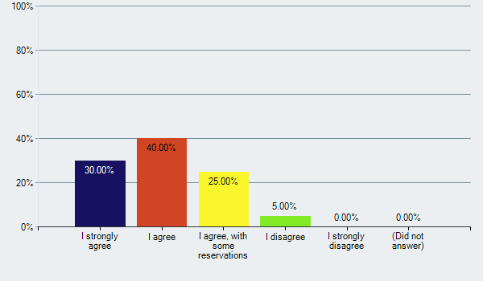

Q17. Please tell us what you like about this statement and the words that resonate with you.
SR No. | Response No. | Response Text
1 | 1 | all of it
2 | 2
3 | 3 | Inclusive Balanced
4 | 4 | inclusive
5 | 5 | General theme and audience referenced.
6 | 6 | I like centers of growth and learning. I like the term curiosity.
7 | 7 | Critical thinking is good
8 | 8 | Growth, learning, curious, critical thinkers
9 | 9
10 | 10 | Best of the bunch. Not terrific.
11 | 11 | Focus is in the over-arching goal, which is provide the facilities, resources and culture to produce well-rounded students who may only be in the APS system for part of their academic careers.
12 | 12 | We are a diverse system, but not necessarily inclusive.
13 | 13 | inclusive, centers of growth, curious & balanced thinkers
14 | 14 | I like the idea but...
15 | 15 | love the idea of inclusive and diverse. I value that highly in my kids' experiences in APS. Schools as "centers of growth and learning" just feels like a place I want to be (and want my kids to be). curious yes! Critical thinkers yes! statement doesn't limit us to just the kids, but could include the entire community in the learning, growing, and thinking. This looks familiar, I think I was part of the team that authored this one.
16 | 16 | I like inclusive and curious and critical thinkers.
17 | 17 | What a wonderful way to describe our schools "inclusive and diverse centers of growth". I like the term "thinkers" and striving to foster curiosity and critical thinking.
18 | 18
19 | 19 | I like that this one focuses on inclusion and diversity
20 | 20 | I like it

Q18. Is there anything you would either omit or change in this statement; if so, what is it?
SR No. | Response No. | Response Text
1 | 1 | NOTHING
2 | 2
3 | 3
4 | 4
5 | 5 | Don't like the word "balanced"
6 | 6 | I am unsure what a "balanced" critical thinker is.
7 | 7
8 | 8 | The statement focuses on schools, which could preclude thinking outside the box about learning opportunities. Possibly change the opening to: APS is inclusive with diverse opportunities for growth and learning that develop curious, balanced, critical thinkers.
9 | 9
10 | 10 | Needs something about academic rigor and challenge.
11 | 11 | maybe describe what kind of growth - spiritual, intellectual, holistic?
12 | 12
13 | 13 | I would suggest putting in something about the community/social/emotional aspect. Critical thinking isn't the only type of thinking, creative should be mentioned as well.
14 | 14 | I want my kids to be more than "curious, balanced critical thinkers." I expect APS to give them skill sets to succeed and ultimately become self-sufficient. I would offer: Arlington schools are inclusive and diverse centers of growth and learning that develop curious, balanced critical thinkers with the skills necessary for success.
15 | 15 | Not keen on the vision being of the schools and not the kids. I'm struggling with that (which is ironic b/c I like the fact that the focus of those schools is broader than just k-12 students.
16 | 16 | I don't think we can claim that the schools are diverse. . because some of them are not. Plus, the addition of the word schools I think makes the system focus a little less clear. And i'm not sure about a "balanced critical thinker" - it's not clear to me what that means.
17 | 17 | I don't understand the balanced piece. I'm not against, but need a bit more context. I suspect others will need so too. I'm worried this vision, is missing the global citizen component that I liked so much from the previous example.
18 | 18
19 | 19 | The descriptors at the end seem to be repetitive and this one doesn’t grab attention
20 | 20 | it's pretty good!

Q19. Please use the space below to provide any other commentary you want to add about the mission and vision to be included in the 2018-24 Strategic Plan.
SR No. | Response No. | Response Text
1 | 1 | I am very hopeful that our wording will support all students, of all ages. We need to make sure that we don't use words like lead or shape because I don't think they convey the idea that students are engaging and learning about themselves as learners. Learners is a word that encompasses the students, the teachers and the families. Focus on wording that describes the success not the word without using the word success.
2 | 2
3 | 3
4 | 4
5 | 5 | I think we need to remain focused on the fact that schools are expected to educate and graduate the students to go through their doors. All of the other mission/vision focus areas are icing on the cake, but if the students are not educated or do not graduate, none of that icing matters.
6 | 6 | Simpler is better. Let's not get caught in educational jargon because this is something the public should be able to read and understand. Keep the jargon for internal work.
7 | 7 | This community does not agree whether diversity should be measured across the district or within each school, or whether it is something that we accommodate or something that we actively foster. The way these statements are worded doesn't stake out a position -- but it would be good if the community was forced to confront some of these issues as part of this process and agree on what we mean when we use these words, because otherwise the Board will just continue to make decisions that a large portion of the community will believe are out of sync with the mission/vision.
8 | 8
9 | 9
10 | 10 | I think we need to remember that the whole point of schools is to educate children--academic rigor and growth should be at the forefront of everything we are talking about. It does no good to have "balanced global citizens ready to impact the world" if they aren't making a year's worth of academic progress each year.
11 | 11 | With all of these mission and vision statements it feels like we the community are telling the students what we are doing for them. What would students write from their perspective? Aren't they partners in achieving the mission and vision? There needs to be some sort of compact between the student and APS.
12 | 12
13 | 13 | APS will aspire to create resilient students who are centered, motivated and enter the world with care and curiosity. I like the words: prepare, cultivate, focus, connect and create as the action words in a mission statement. I think looking at the charge, it makes it very simple. Focus on students as our core priority. Connect the potential with promise.
14 | 14 | In the end it is about students being prepared to succeed.
15 | 15 | I look forward to what comes out of the ones we're looking at. Lots of superb, aspirational concepts and ideas!
16 | 16
17 | 17
18 | 18
19 | 19
20 | 20 | Some work may be needed to balance the Mission and Vision such that they complement or at least align with each other. Not sure the choices presented here meet that criteria, but then I am not looking at them side by side.

