PERFORMANCE ASSESSMENT TASK
Grade 7: Audio Tour of the Franklin Delano Roosevelt Memorial

UNIT VIII: Boom to Bust: The Role of Government Expands

STANDARDS: CE.13b,c,e,f USII.6d

ENDURING UNDERSTANDING: Government intervention may be necessary in times of crisis to meet the changing needs of society.

CONCEPTUAL UNIT QUESTION: What role should the government play in the daily lives of its citizens?

SCENARIO: You are a National Parks Service ranger at the Franklin Delano Memorial in Washington D.C. The National Park service has been receiving feedback from visitors requesting more information. Visitors are requesting more information about
- the Great Depression and the government’s response.
- the New Deal and the support and criticism of FDR’s expansion in the role of government.
- the government response during the Great Depression as it relates to how the federal government addresses current economic problems.
- your opinion about how much the federal government should intervene in current economic problems of the country.

TASK: You will collect information from the documents to
- identify and describe the purpose of specific New Deal programs
- identify and describe different points of view in regard to the federal government’s intervention during the Great Depression.
- narrate an audio tour that uses attached memorial photographs to educate visitors to the memorial about the New Deal programs, the support and criticism of such government intervention, and how the New Deal is connected to how the government addresses current economic problems.

DOCUMENT: Use each of the attached documents provided to research information on your task.
Document A: Table of New Deal Programs
Document B: Excerpts from President Franklin Roosevelt’s speeches on
government intervention
Document C: Cartoon criticizing the New Deal.
Document D: Excerpts from President Herbert Hoover speech on government
intervention
Document E: Unemployment Graph, 1929-1945
Document F: 2010 Gallup Poll Graph -American’s views on government
intervention
Document G: FDR Memorial Photo Tour

PRODUCT: You will produce an audio tour that
- describes the government’s response to the Great Depression
- identifies and describes New Deal programs, using content related vocabulary
- Represents arguments for and against government intervention during the Great Depression
- makes connections between the government actions to solve the nation’s economic problems of the 1930’s to develop an in-depth position on the role of the federal government in current economic problems
- provides a clear, organized educational guide to the memorial for visitor
- specifically incorporates evidence from at least THREE documents included in the task

PAT RUBIC: Boom to Bust: The Role of Government Expands
Category | 4 Exceeds Expectations | 3 Meets Expectations | 2 Approaching Expectations | 1Below Expectations | Score
Content | Demonstrates thorough and accurate understanding of the federal government’s response to the Great Depression. | Demonstrates a complete and accurate understanding of the federal government’s response to the Great Depression. | Demonstrates an incomplete understanding of the federal government’s response to the Great Depression. | Demonstrates inaccuracies and misconceptions about the federal government’s response to the Great Depression.
Basic Skills | Identifies and thoroughly describes specific New Deal programs without error. | Identifies and describes specific New Deal programs, without significant error. | Demonstrates a number of errors when describing specific New Deal programs but can complete a basic identification of them. | Demonstrates many critical errors when identifying and describing specific New Deal programs.
Analysis/Interpretation  Skills | Examines thoroughly all of the given documents.  Analyzes and evaluates information to identify different points of view on the federal government’s response to the Great Depression. | Examines several of the given documents.  Makes a credible effort to analyze and evaluate information from some of the documents to identify different points of view on the federal government’s response to the Great Depression. | Examines some of the given documents.  Makes little effort to analyze and/or evaluate information to identify different points of view on government’s response to the Great Depression. | Gives no evidence that given documents were examined.  Fails to analyze and evaluate information different views on the federal government’s response to the Great Depression.
Application/Synthesis  Skills | Cites and elaborates on evidence from at least three of the given documents to develop an in-depth position on what role the federal government should play in solving economic problems. | Cites some evidence from 1-2 of the given documents to identify a position on what role the federal government should play in solving economic problems. | Cites some evidence from the given documents to restate information.  Does not construct a position on what role the federal government should play in solving economic problems. | Cites no evidence from the given documents.  Does not construct a position on what role the federal government should play in solving economic problems.
Communication Skills | Product is well organized with clearly stated, complex ideas supported by citations from the documents and effectively conveys the message. | Product is somewhat organized with clearly stated basic ideas supported by citations from the documents, and adequately conveys the message. | Product is poorly organized. Ideas are unclear, weakly supported by the documents and poorly conveys the message. | Product is unorganized with irrelevant statements and no document citations and fails to convey the message.

Document A

Table of New Deal Programs
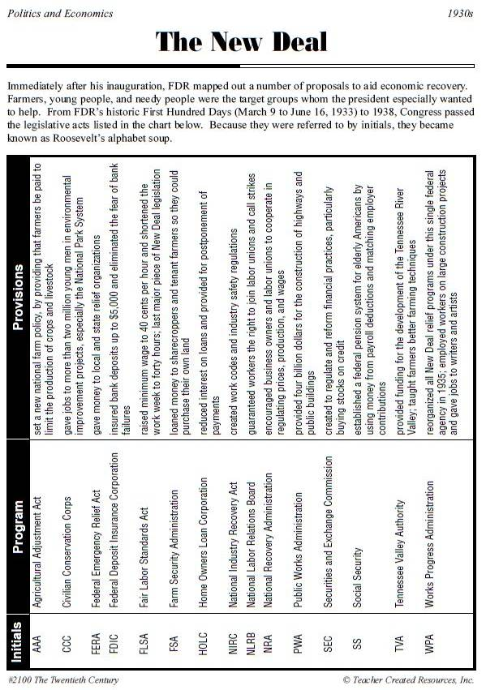

Document B
Excerpts from President Roosevelt’s speeches on government intervention

Excerpt 1
GLOSSARY
relief –getting money from the government because they are poor or unemployed
not local but national –means that the problem was a nation-wide problem
sufficient—enough
credit – money that can be borrowed
assumed—taken-on; take responsibility for
shrink from it—quit doing it
pending –waiting on
Absorption – To be taken in
Tide – Large and increasing quantity or volume
There [are] three and one half million employable people who are on relief; with them the problem is different and the responsibility is different. This group was the victim of a nation - wide depression caused by conditions which were not local but national. The Federal Government is the only governmental agency with sufficient power and credit to meet this situation. We have assumed this task and we shall not shrink from it in the future. It is [clearly important for the government] to ask you to make it possible for the United States to give employment to all of these three and one half million employable people now on relief, pending their absorption in a rising tide of private employment.

Adapted text from speech given by President Franklin Delano Roosevelt,
January 4, 1935
Reprinted in The Public Papers and Addresses of
Franklin D. Roosevelt, Vol. 4, 1935,
(New York City: Random House, 1938)

-----------------------------------------------------------------------------------------
Excerpt 2
GLOSSARY

withdraw from giving –stop giving
perhaps –maybe
local—meaning, something that the city (not national) government needs to fix
Grudging – Unwilling, reluctant
starvation wages –earning so little money at a job that you are still starving
lies not within the province –is not the responsibility
relief –getting money from the government because they are poor or unemployed
Squalor – Filthiness, neglect
Reduction –decrease
Advance—continue to do what is already being done
Mandate—the job of speaking for, and helping the people who voted for a leader
Shall we say to the several millions of unemployed citizens who face [starvation], "We will withdraw from giving you work. We will turn you back to the charity of your communities and those men of selfish power who tell you that perhaps they will employ you if the Government leaves them strictly alone?"
Shall we say to the needy unemployed, "Your problem is a local one [and all the Federal government will do to help] is pay to your city or to your county a few grudging dollars to help maintain your soup kitchens?"
Shall we say to the children who have worked all day in the factories, "Child labor is a local issue and so are your starvation wages; something [the separate] forty-eight States [have to fix]?"

Document B cont.

lies not within the province –is not the responsibility
relief –getting money from the government because they are poor or unemployed
Squalor – Filthiness, neglect
Reduction –decrease
Advance—continue to do what is already being done
Mandate—the job of speaking for, and helping the people who voted for a leader

Shall we say to the unemployed and the aged, "Social security lies not within the province of the Federal Government; you must seek relief elsewhere?"
Shall we say to the men and women who live in conditions of squalor in country and in city, "The health and the happiness of you and your children are no concern of ours?" […]
I am confident that the Congress of the United States well understands the facts and is ready to wage unceasing warfare against those who [say we should abandon the programs of the New Deal]. […]
National income increases; employment increases. Therefore, we can look forward to a reduction in the number of those citizens who are in need. […]
In the light of our [great] progress, [I] recommend to the Congress that we advance; that we do not retreat. I have confidence that you will not fail the people of the Nation whose mandate you have already so faithfully fulfilled. […]

Adapted text from speech given by President Franklin Delano Roosevelt
January 3, 1936
Reprinted in The Public Papers and Addresses
of Franklin D. Roosevelt, Vol. 5, 1936
(New York City: Random House, 1938)

Document C
Cartoon Criticizing the New Deal

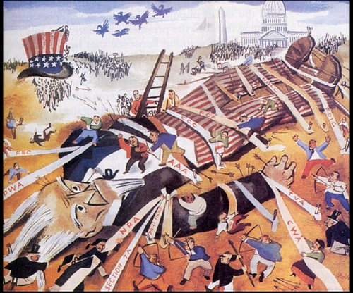

Think About it:
1. What is happening to Uncle Sam?

2. What do the ties/ropes represent?

3. People have different ideas about the role of government. Liberals believe the government should play a larger role; conservatives believe the government should play a smaller role. What view does the illustrator most likely represent in this cartoon?

Document D
Excerpts from President Herbert Hoover’s speech on government intervention

GLOSSARY

Extend—expand; stretch
mastery of government—control or power of the government
Stifle – To cut off, not allowed to express
Enterprise –Economic or business action
alter –change
rejected –did not want
Notion – idea
Delay—slow
Shackle – chain; preventing free action

Speaking just four years ago [in] 1932 , I said, “… you cannot extend the mastery of government over the daily life of a people without somewhere making it master of people’s souls and thoughts.
The New Deal … stifle(s) the growth of small business and discourage(s) new enterprise. By stifling private enterprise the [government will increase its power more easily] …
…the President has seized the power to alter all wages, all price, all debts, all savings at will …
During my four years… I rejected the notion of great trade monopolies … I rejected the [plans that would control what farmers grew] … I refused national plans to put the government into … competition with its citizens …
I rejected all these things because they would not only delay recovery but because I knew that in the end they would shackle free men …

Adapted text from speech given by Herbert Hoover, former president
From the “Challenge to Liberty”
speech, October 1936

Document E
Unemployment Graph, 1929-1945

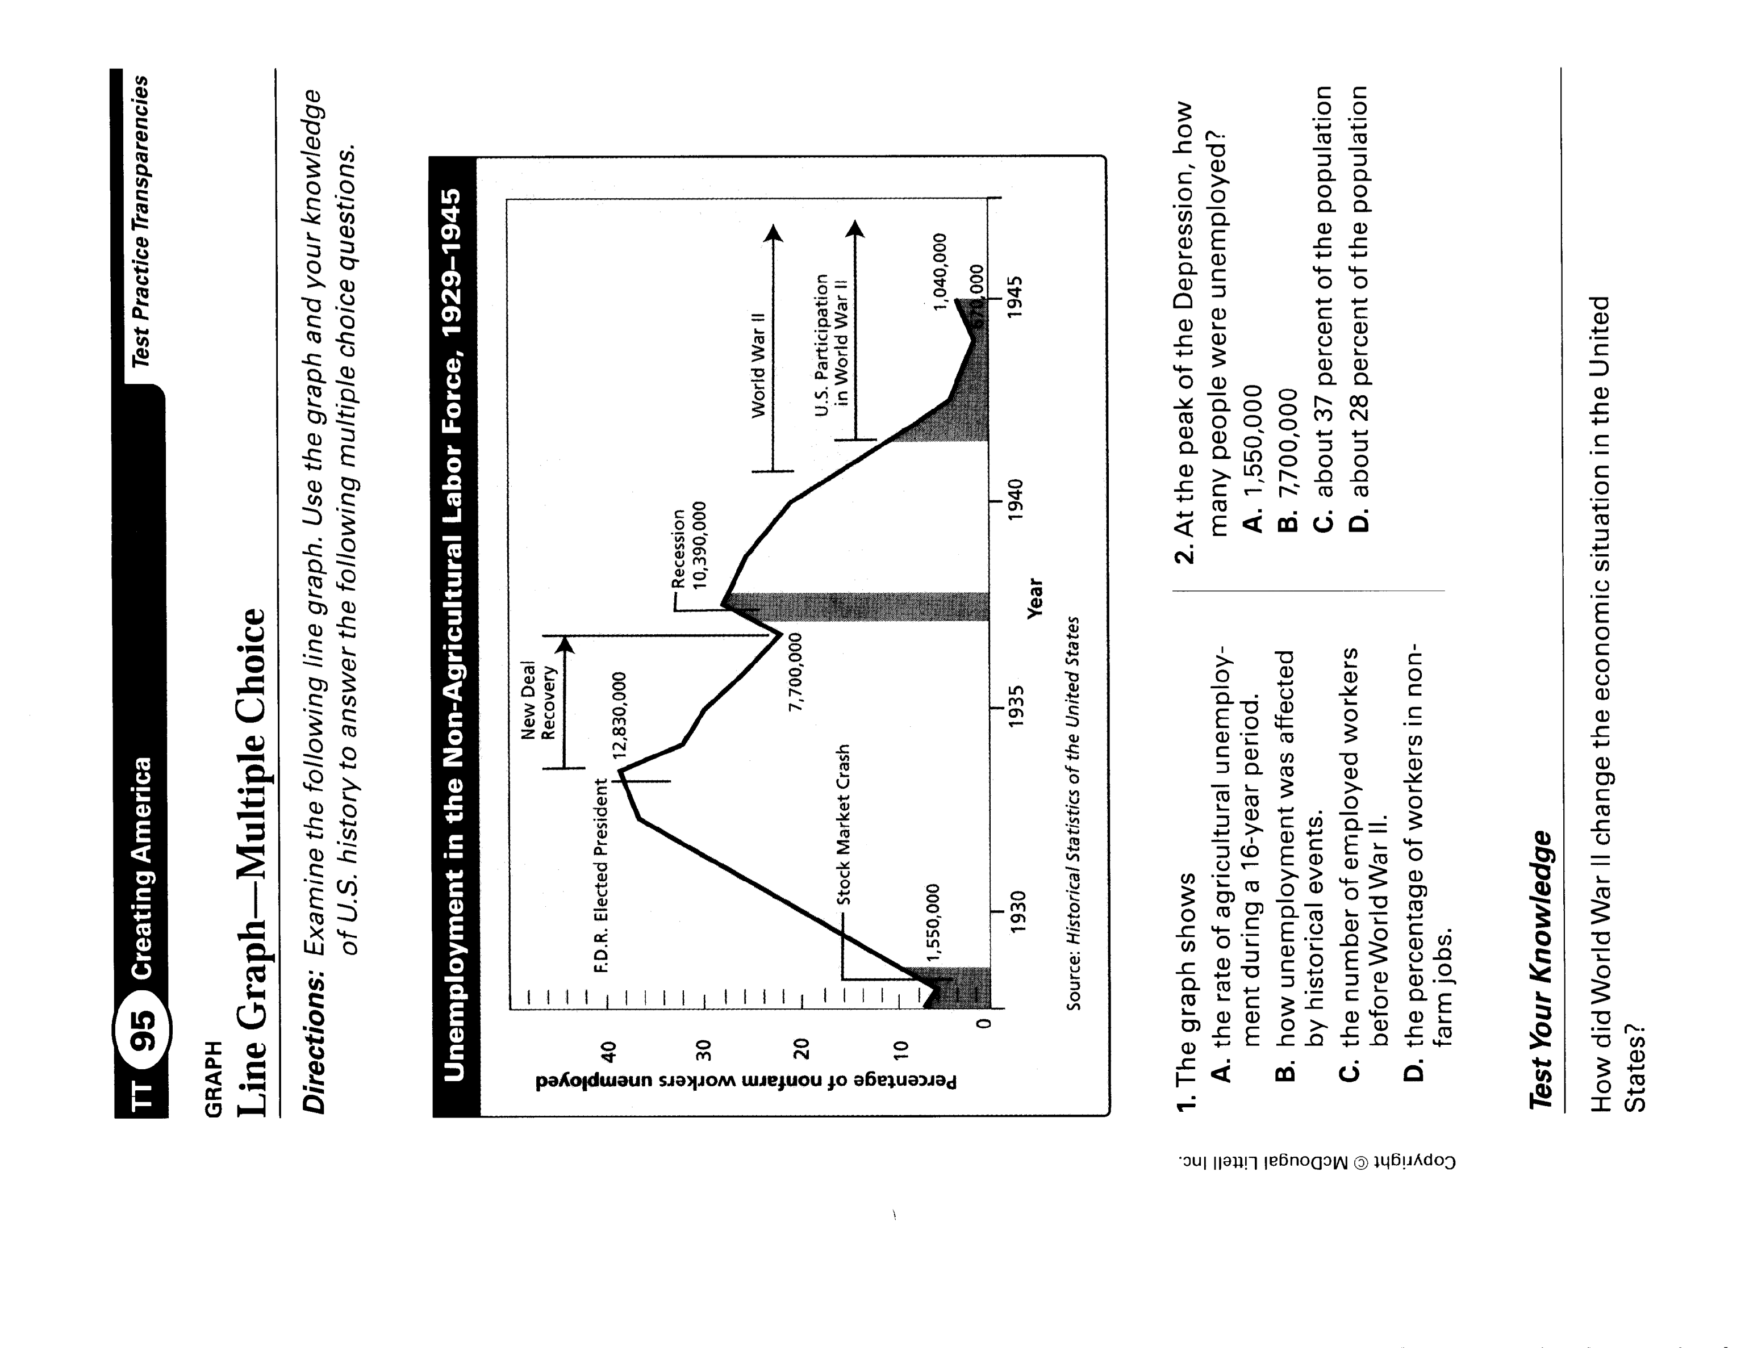
Document F
2010 Gallup Poll Graph -American’s views on government intervention

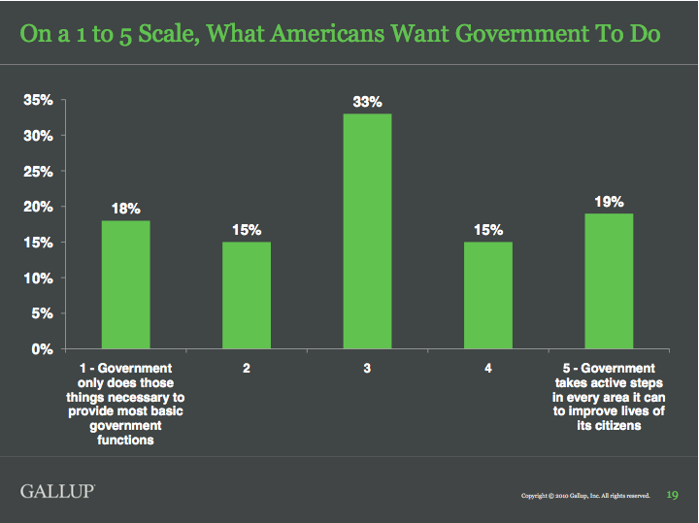

In a 2010 survey conducted by the Gallup Organization, Americans were asked to consider the role of government in today’s society. Those participating in the survey used a scale from 1 to 5. A response of 1 meant “government should only do things necessary to provide the most basic government functions.” A response of 5 means, “government should take active steps in every area to improve the lives of its citizens.”

Document G: FDR Memorial Photo Tour
(see Powerpoint)

PAT DOCUMENT ORGANIZER: Boom to Bust- The Role of Government Expands
Evidence Chart | Task Skill:  Identify and describe the purpose of the New Deal. | Task Skill:  Explain two points of view toward government intervention. | Task Skill:  Describe attitudes toward the role of government today.
Document A

Table of New Deal Programs
Document B

FDR Speech Excerpt
Document C

New Deal Cartoon
Document D

Hoover Speech Excerpt

Document E

Hoover Speech Excerpt
Document F

Unemployment Graph 1929-1945
Document G

FDR Memorial Photo Tour

PLANNING YOUR AUDIO TOUR OF THE FDR MEMORIAL

Remember: You are a National Park Service ranger at the FDR Memorial and you have been asked to design an educational audio tour through the part of the memorial that deals with the Great Depression. In response to visitors’ questions, your boss has asked you to specifically talk about:
- What was the Great Depression and how did the government respond to it?
- What was the New Deal and what were some positive and negative reactions to this expansion in the role of government?
- How is the government’s response during the Great Depression relevant to how the federal government addresses current economic problems?
- What is your opinion about how much the federal government should intervene to solve the economic problems of the country?

Use the planning guide below to help you select where you will have visitors stop and what you will say at each stop.

Location(s)/  Slide(s) Used: | What was the Great Depression? What caused this economic and social crisis? How did the Great Depression affect the American people?

Location(s)/  Slide(s) Used: | Who was FDR? What did he believe government ought to do to solve the economic problems of the Depression?

Location(s)/  Slide(s) Used: | What was the New Deal? What was its purpose?
Location(s)/  Slide(s) Used: | What were some specific New Deal programs and how were they supposed to help?

Location(s)/  Slide(s) Used: | What was the public’s reaction to the New Deal? What support and criticism did the New Deal receive?

Location(s)/  Slide(s) Used: | How does this relate to how the government handles today’s economic problems? What connections can you make for visitors between the role of government in the past and today?  AND  What do YOU think? What role should the government play in solving the economic problems of the country?

When you have finished planning your tour, use the technology program assigned by your teacher to record your narration with the slides you have chosen.

PAT Score Form

Teacher: Unit #: Date: ____________

Student Name | Content |  |  |  | Basics |  |  |  | Analysis |  |  |  | Application |  |  |  | Communication |  |  |  | Total
Student Name | 4 | 3 | 2 | 1 | 4 | 3 | 2 | 1 | 4 | 3 | 2 | 1 | 4 | 3 | 2 | 1 | 4 | 3 | 2 | 1 | Total

