MINI-PERFORMANCE ASSESSMENT TASK SCAFFOLDED
Grade 7

UNIT VIII: Boom to Bust: The Role of Government Expands

STANDARDS: CE 13.b,c,e,f; USII.6d

ENDURING UNDERSTANDING: Government intervention may be necessary in times of crisis to meet the changing needs of society.

CONCEPTUAL UNIT QUESTION: What role should the government play in the daily lives of its citizens?

SCENARIO: You are a National Parks Service ranger at the Franklin Delano Memorial in Washington D.C. You are giving a tour. You are now showing visitors the part of the park where there are tiles explaining the New Deal laws made during the Great Depression. One child in the group asks you the following question: “How did President Roosevelt help people during the Great Depression?” Your task will be to answer that question.

TASK: You will collect information from the provided documents to
- identify and describe the purpose of specific New Deal programs
- explain how these programs helped Americans during the Great Depression.

DOCUMENT: Use the attached documents provided to research information on your task.
Document A: Table of New Deal Programs (with 8 laws highlighted)

PRODUCT: You will produce a short paragraph response to the student question that
- describes some of the New Deal programs
- explains how those programs helped Americans during the Great Depression
- uses content related vocabulary including specific New Deal programs
- provides a clear, organized response to the student question

ADDITIONAL RESOURCES:
- Picture of FDR memorial monument
- PAT Graphic Organizer for taking notes
- Rubric
- Template for writing task

PAT RUBIC: Boom to Bust: The Role of Government Expands
Category | 4 Exceeds Expectations | 3 Meets Expectations | 2 Approaching Expectations | 1Below Expectations | Score
Content | Demonstrates thorough and accurate understanding of the federal government’s response to the Great Depression. | Demonstrates a complete and accurate understanding of the federal government’s response to the Great Depression. | Demonstrates an incomplete understanding of the federal government’s response to the Great Depression. | Demonstrates inaccuracies and misconceptions about the federal government’s response to the Great Depression.
Basic Skills | Identifies and thoroughly describes specific New Deal programs without error. | Identifies and describes specific New Deal programs, without significant error. | Demonstrates a number of errors when describing specific New Deal programs but can complete a basic identification of them. | Demonstrates many critical errors when identifying and describing specific New Deal programs.
Analysis/Interpretation  Skills | Examines thoroughly all of the given documents.  Analyzes and evaluates information to identify different points of view on the federal government’s response to the Great Depression. | Examines several of the given documents.  Makes a credible effort to analyze and evaluate information from some of the documents to identify different points of view on the federal government’s response to the Great Depression. | Examines some of the given documents.  Makes little effort to analyze and/or evaluate information to identify different points of view on government’s response to the Great Depression. | Gives no evidence that given documents were examined.  Fails to analyze and evaluate information different views on the federal government’s response to the Great Depression.
Application/Synthesis  Skills | Cites and elaborates on evidence from at least three of the given documents to develop an in-depth position on what role the federal government should play in solving economic problems. | Cites some evidence from 1-2 of the given documents to identify a position on what role the federal government should play in solving economic problems. | Cites some evidence from the given documents to restate information.  Does not construct a position on what role the federal government should play in solving economic problems. | Cites no evidence from the given documents.  Does not construct a position on what role the federal government should play in solving economic problems.
Communication Skills | Product is well organized with clearly stated, complex ideas supported by citations from the documents and effectively conveys the message. | Product is somewhat organized with clearly stated basic ideas supported by citations from the documents, and adequately conveys the message. | Product is poorly organized. Ideas are unclear, weakly supported by the documents and poorly conveys the message. | Product is unorganized with irrelevant statements and no document citations and fails to convey the message.

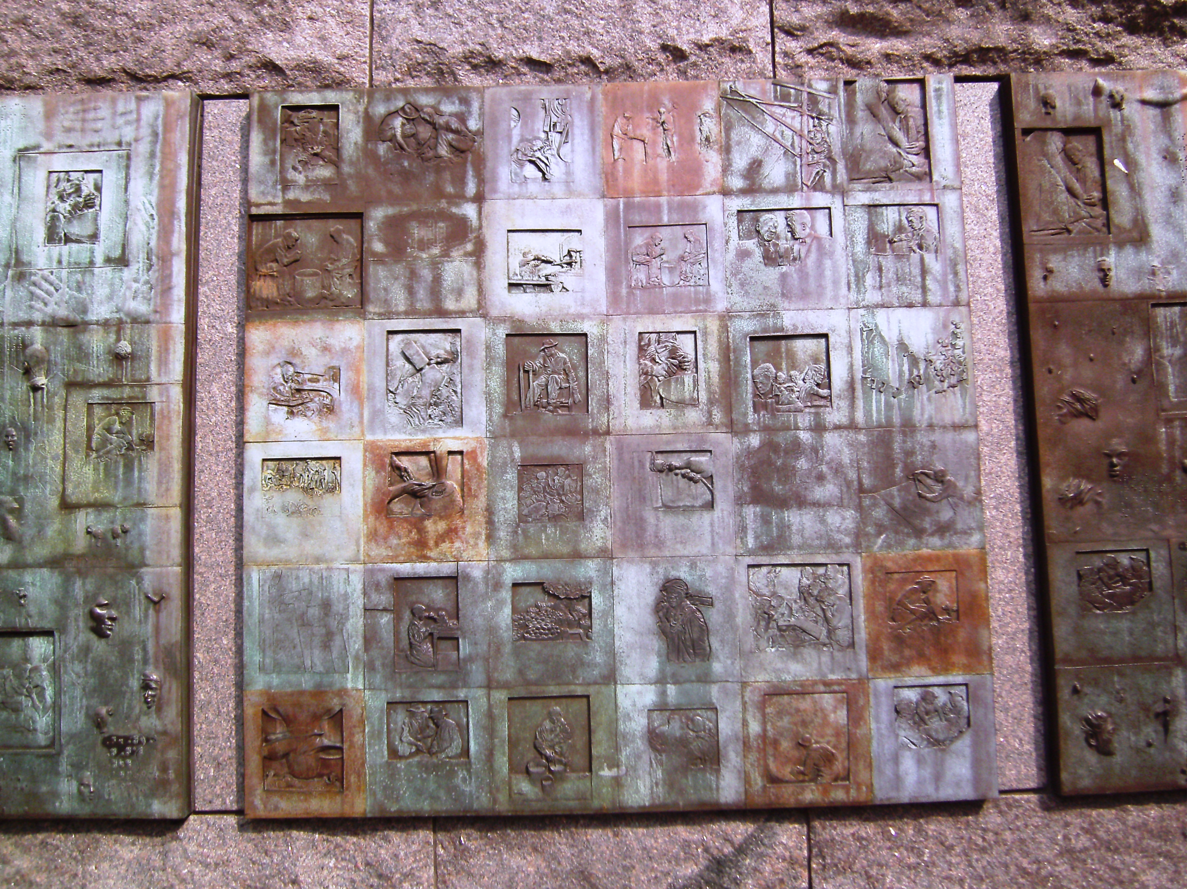

ROOSEVELT MEMORIAL

Document A
Table of New Deal Programs

Initials | Program | Provisions
AAA | Agricultural Adjustment Act | Farm Assistant Program that paid farmers to limit how much livestock and crops they produced
CCC | Civilian Conservation Corps | Environmental improvement plan that hired young men to improve national parks and other projects
WPA | Works Progress Administration | Federal works program that hired workers for large construction projects and gave jobs to writers and artists
FLSA | Fair Labor Standards Act | Raised the minimum wage to 40 cents an hour and shortened the work week to 40 hours.
NLRB | National Labor Relations Board | Increased rights for workers and guaranteed workers the right to join labor unions and call strikes.
SS | Social Security | Established a federal pension/retirement system for senior citizens.
SEC | Security Exchange Commission | Agency created to monitor and regulate banking and stock markets.
TVA | Tennessee Valley Authority | Provided funding to build dams and develop the Tennessee River Valley.
FERA | Federal Emergency Relief Act | Gave money to local and state relief organizations.

DOCUMENT STUDY CHART
MINI PAT SCAFFOLDED
Directions: As you study Document A, record what you learn in the spaces below

New Deal Law  What was it called? | What did this New Deal law do? | How did this law help people?

Writing Template Name _________________________

Question: How did President Roosevelt help people during the Great Depression?
First tell the child who Franklin Roosevelt was, using a complete sentence.
__________________________________________________________
__________________________________________________________
__________________________________________________________

Next, tell what President Roosevelt wanted to do to help people during the Great Depression.
__________________________________________________________
__________________________________________________________
__________________________________________________________

Describe some of the New Deal Laws and how they helped Americans during the Great Depression.

1.________________________________________________________
__________________________________________________________
__________________________________________________________

2. _______________________________________________________
__________________________________________________________
__________________________________________________________

3. ________________________________________________________
__________________________________________________________
__________________________________________________________

Conclude your response with your opinion on whether FDR’s programs were necessary to solve the Great Depression.
__________________________________________________________
__________________________________________________________
__________________________________________________________
____________________________________________________________

PAT Score Form

Teacher: Unit #: Date: ____________________

Student Name | Content |  |  |  | Basics |  |  |  | Analysis |  |  |  | Application |  |  |  | Communication |  |  |  | Total
Student Name | 4 | 3 | 2 | 1 | 4 | 3 | 2 | 1 | 4 | 3 | 2 | 1 | 4 | 3 | 2 | 1 | 4 | 3 | 2 | 1 | Total

